
King George Avenue
Ilkeston
Derbyshire
DE7 5HS

0115 9303724

Dear Parents and Carers,
Firstly, I would like to pay tribute to all the hard work that Nia Salt has put into OIEA over the last 7 years. I am grateful that as we start this academic year, we have the foundations in place to continue the academy’s improvement journey.

The GCSE results this year reflect a huge amount of hard work and dedication from our Y11 students, and I wish them all the best with their future endeavours.

I am extremely excited to take on the Interim Principal position. I am very passionate about supporting our students’ development and I will work tirelessly to ensure all students receive the good standard of education that they deserve.

Since join the Academy in April 2022, I have worked closely with the academy leadership team and more widely with the Ormiston Academy Trust to improve the standards across the academy. This work will continue, as improvements in both student attainment and behaviour will be remain a high priority over the next year.
I am pleased to say I will be closely supported by Rod Hughes, an Education Director at OAT. Rod is an experienced leader, having been a successful Principal in two OAT schools for the past 11 years, and will be based at Ormiston Ilkeston Enterprise Academy two days a week for the coming term. Alongside Rod, I will have the support of the wider OAT team, as well the strong senior leadership team in place at Ormiston Ilkeston Enterprise Academy.

I have very high expectations on student conduct and will not tolerate students disrupting the learning of other students. I thank you in advance for your support on this, as I know that you will agree that disruption free classrooms are the bedrock of academic success.

Following on from the pandemic attendance across the academy will also need to significantly improve this year. I would like to remind all parents that attendance between 100- 96% is expected from all students. No term time holidays will be permitted, and it is disappointing that fixed term penalties were still issued for some parents last year who took holiday in term time. After all the missed education over the last 2 years, all students need to be in school 100% of the time.

Below is a reminder of the start of term arrangements and a reminder on uniform expectations. Please read these carefully.

Monday 5th September- Year 7 only
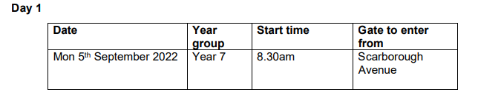

Tuesday 6th September- Year 7, 10 & 11
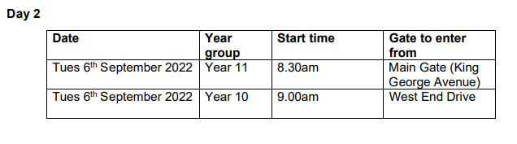
Wednesday 7th September- All Year groups
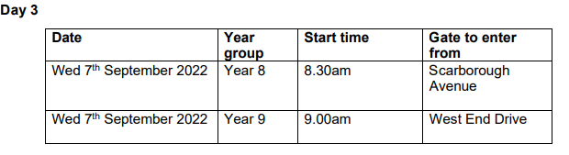

Uniform
Please see the academy website for uniform expectations. Please ensure that your child has all required uniform for the new term.
https://www.oiea.co.uk/key-info/uniform

Mobile Phones
Reminder that students are not permitted to use or be seen with their mobile phones whilst on the Academy site. Please ensure phones are kept away in bags or blazer pockets.
I am greatly looking forward to the term ahead and getting to know our new year 7 students joining the Academy. I look forward to working in partnership with all staff, students, Governors and parents over the coming year.

Warm regards,

Simon Glover
Interim Principal

